Ex.No:1: Simulation of FDMA in MATLAB
Aim: To simulate a Frequency Division Multiple Access (FDMA) system using MATLAB and analyze its communication performance in terms of channel bandwidth, data rate, and signal-to-noise ratio (SNR).
Program
Objective 1:
clc;
clear;
close all;
fs=1000;
t=0:1/fs:1;
TBW=600;
Users=3;
CBW=TBW/Users;
fc=[100 300 500];
m=sin(2*pi*10*t);
s1=m.*cos(2*pi*fc(1)*t);
s2=m.*cos(2*pi*fc(2)*t);
s3=m.*cos(2*pi*fc(3)*t);
subplot(2,1,1)
plot(t,s1,'r',t,s2,'g',t,s3,'b')
grid on
title('FDMA Channel Allocation')
xlabel('Time (s)'),ylabel('Amplitude')
subplot(2,1,2)
bar(1:Users,CBW*ones(1,Users))
grid on
xlabel('Users')
ylabel('Channel Bandwidth (kHz)')
title('Channel Bandwidth per User')
output:
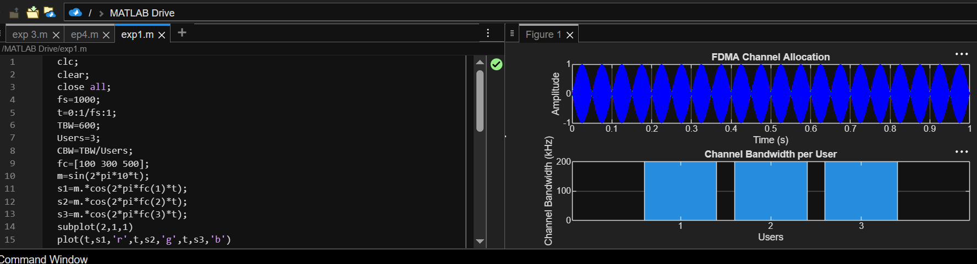

Objective 2:
clc;
clear;
close all;
BW = 200;
Users = 3;
M = 2;
DataRate = BW*log2(M);
Rate = DataRate*ones(1,Users);
disp(' User Data Rate (kbps)')
disp([(1:Users)' Rate'])
figure
bar(1:Users,Rate)
xlabel('Users')
ylabel('Data Rate (kbps)')
title('FDMA Data Rate for Each User')
grid on
output:
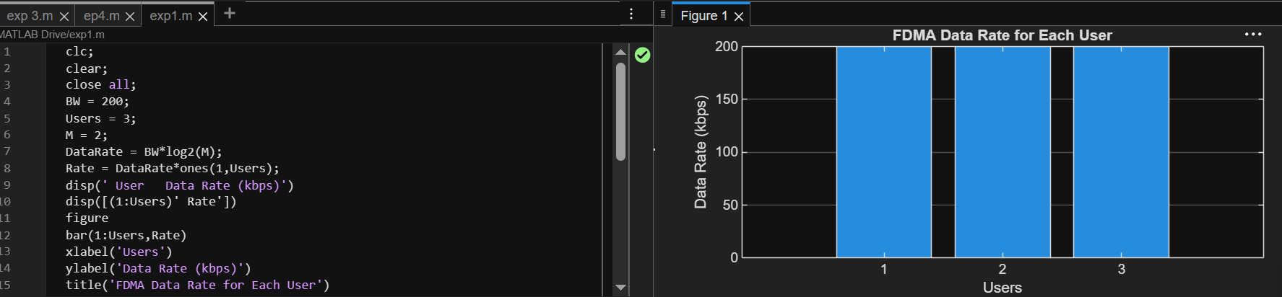
Objective 3:
clc;
clear;
close all;
Ps = 1;
Pn = [0.1 0.05 0.01];
Users = 1:3;
SNR = 10*log10(Ps./Pn);
disp('User Noise Power(W) SNR(dB)')
disp([Users' Pn' SNR'])
figure
bar(Users,SNR)
xlabel('Users')
ylabel('SNR (dB)')
title('Signal-to-Noise Ratio of FDMA Users')
grid on
output:
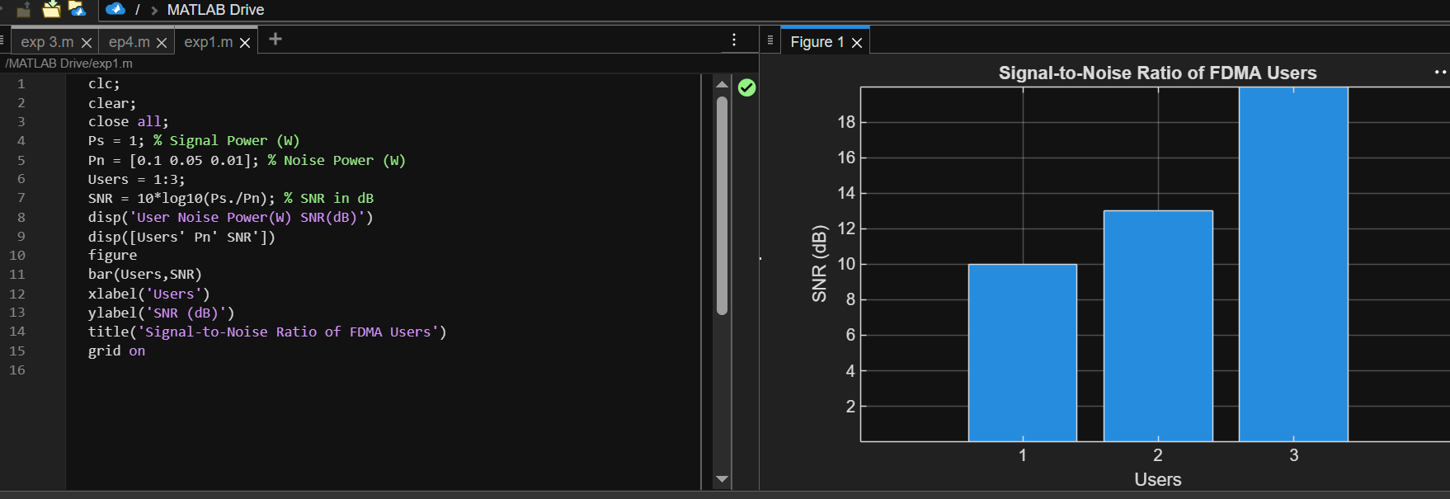
Result:
1. The FDMA system was successfully simulated by allocating separate frequency channels to three users, and the channel bandwidth assigned to each user was determined.
2. The data rate achieved by each user was successfully calculated based on the allocated channel bandwidth, demonstrating equal transmission capacity for all users.
3. The Signal-to-Noise Ratio (SNR) for different users was successfully evaluated, showing that higher SNR values provide better communication quality and reliable data transmission.

